Miguel Tirado

Professor Rudametkin

ENGR117-06

9/26/2016

**Pre-lab 3: Oscilloscope**

**Part I Vertical Controls**

Observe the trace and caret as the vertical position knob (in the vertical control section) for channel #2 is rotated.

Observations:

Measure the peak to peak calibrator voltage with the on-screen probe control in the X1 and X10 positions. Which do you think is the correct reading?

Observations:

X1 (1M)  = _____V

X1 peak to peak voltage = _____V

X10 (10M)  = ____V

X10 peak to peak voltage = _____V

Which is the correct reading? Answer:

First we have to set channel one to DC and the probe to x10, next will use the x10 probe and connect to the function generator. Note that we have two choices of function generators to use in this lab, one being the discrete function generator and the second is the built-in function generator on the oscilloscope. My team and I choose the built-in function generator and set the frequency to 1KHZ sinusoidal with a I volt peak t peak amplitude. Next the oscilloscope’s time base had to be adjusted to about 4 cycles on the wave. Finally set a DC offset of 1 volt on the function generator.

Observations:

0 volts DC offset:

1 volt DC offset:

Change the channel coupling (from the on-screen menu) from DC to AC.  Now what happened to the trace? Provide explanations for your observations.

Observations:

Figure 1. RC Circuit

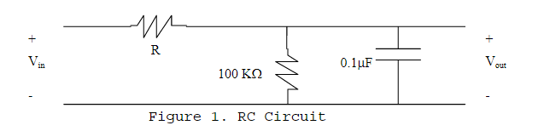

Connect Channel #1 of the oscilloscope to Vin and Channel #2 to Vout.  You should now observe the relative time position of the circuit input and the circuit output on the oscilloscope.  Sketch these waveforms.

Observations:

                         Channel 1                          Channel 2

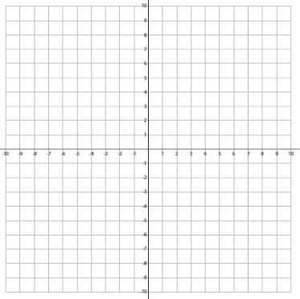                       

**Part II Triggering Controls**

|  |  |
| --- | --- |
| Observe When: | Observations: |
| Trigger Level Changes |  |
|
| Toggled from + to - |  |
|
| Toggled from "AUTO" to "NORM" (Within the signal voltage) |  |
|
| Toggled from "AUTO" to "NORM" (Outside the signal voltage) |  |
|

**Part III Measurements**

|  |  |  |  |  |  |  |
| --- | --- | --- | --- | --- | --- | --- |
| Element | Voltage | Frequency | Time Delay | Period | Phase Shift ( | Magnitude |
| RMS Waveform 1(measured) |  |  |  |  |  |  |
| RMS Waveform 1(calculated) |  |  |  |  |  |  |
|  |  |  |  |  |  |  |
| RMS Waveform 2(measured) |  |  |  |  |  |  |
| RMS Waveform 2(calculated) |  |  |  |  |  |  |
|  |  |  |  |  |  |  |
| RMS Waveform 3(measured) |  |  |  |  |  |  |
| RMS Waveform 3(calculated) |  |  |  |  |  |  |

**R Calculation:**

